cs_logo-143x53

Develop a mini-Carsales application

**Summary**

Developed application which currently handle the sale of vehicle type car but have capability to add other types of vehicles as well.

For Demo purpose I have added Bike Vehicle along with car.

**Must Steps:**

1. After cloning the code and automatic installation of package, do open task runner explorer and click on build and dev option.
2. Run the code and in browser press F12 and right click on the refresh icon and click on refresh cache and hard reload option.
3. Yipee!!! That’s it .Application should run as expected.

**Technical Details:**

1. Form:

Possibility: We can use one form for all vehicles by conditionally rendering fields as implemented in VehicleForm.js. Also we can create separate form which is vehicle specific like I created CarForm.js.

Implemented: But in this application I have used VehicleForm for all types of vehicles and carForm for car vehicle.

1. Models:

Possibility: we can use vehicle specific models or common model with nested vehicle specific model.

Implemented: I have used common model in this application.

1. Controller Action method for submission:

Possibility: we can use vehicle specific method or common method with dependency injection.

Implemented: I have used common method with dependency injection in this application so that when we add new vehicle type we don’t have to change much in our application.

Implemented scope of expansion using interface and dependency injection. This can also be achieved by abstract Factory pattern.

**Screenshots:**

1. On load below screen will show up, Select vehicle type from dropdown.

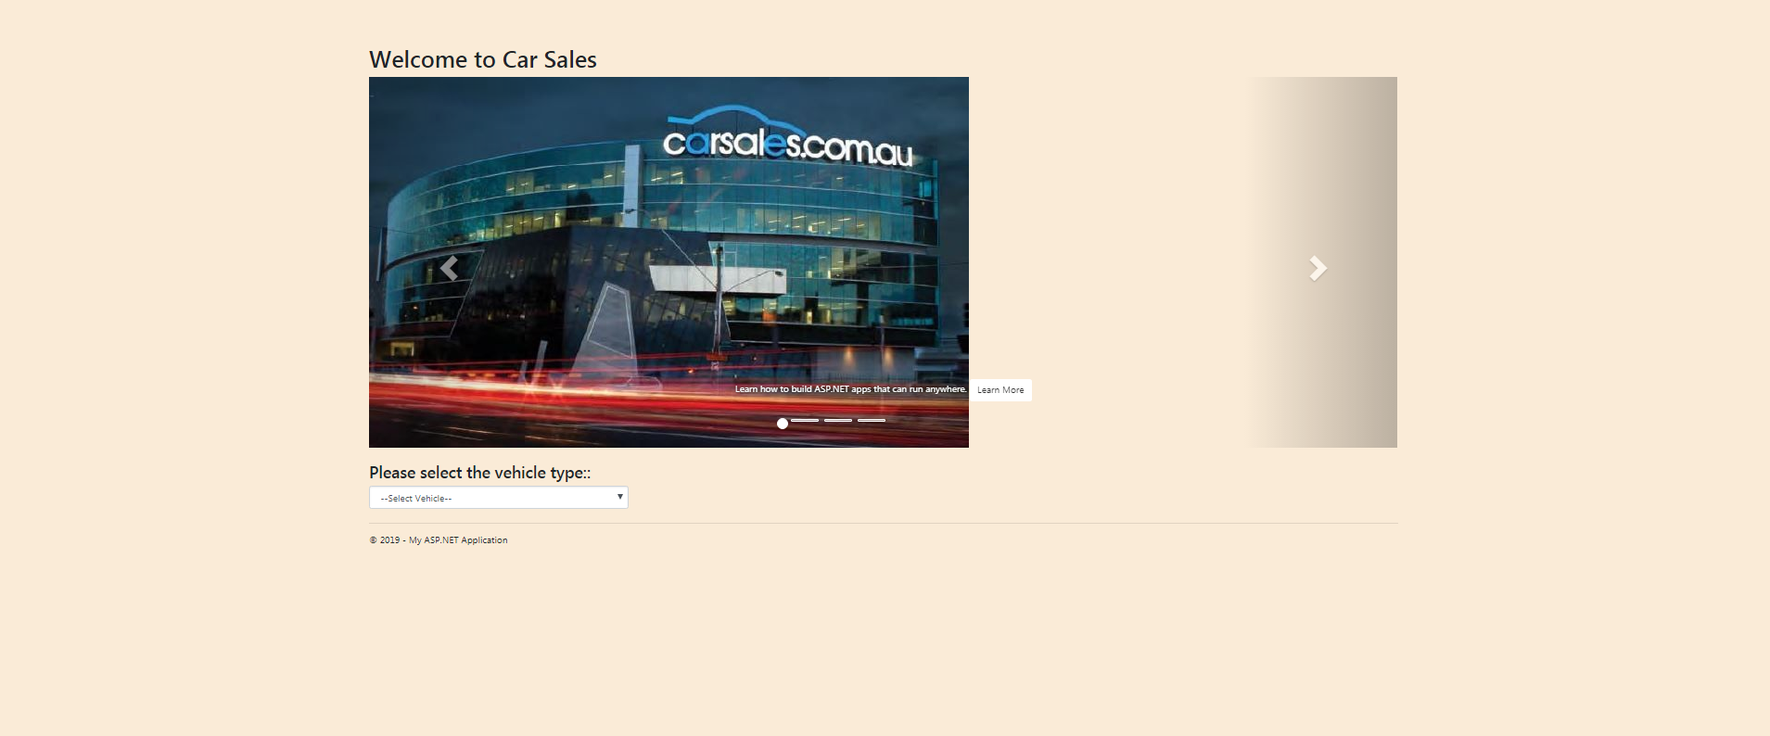

1. On selecting vehicle type from dropdown below screen will display .

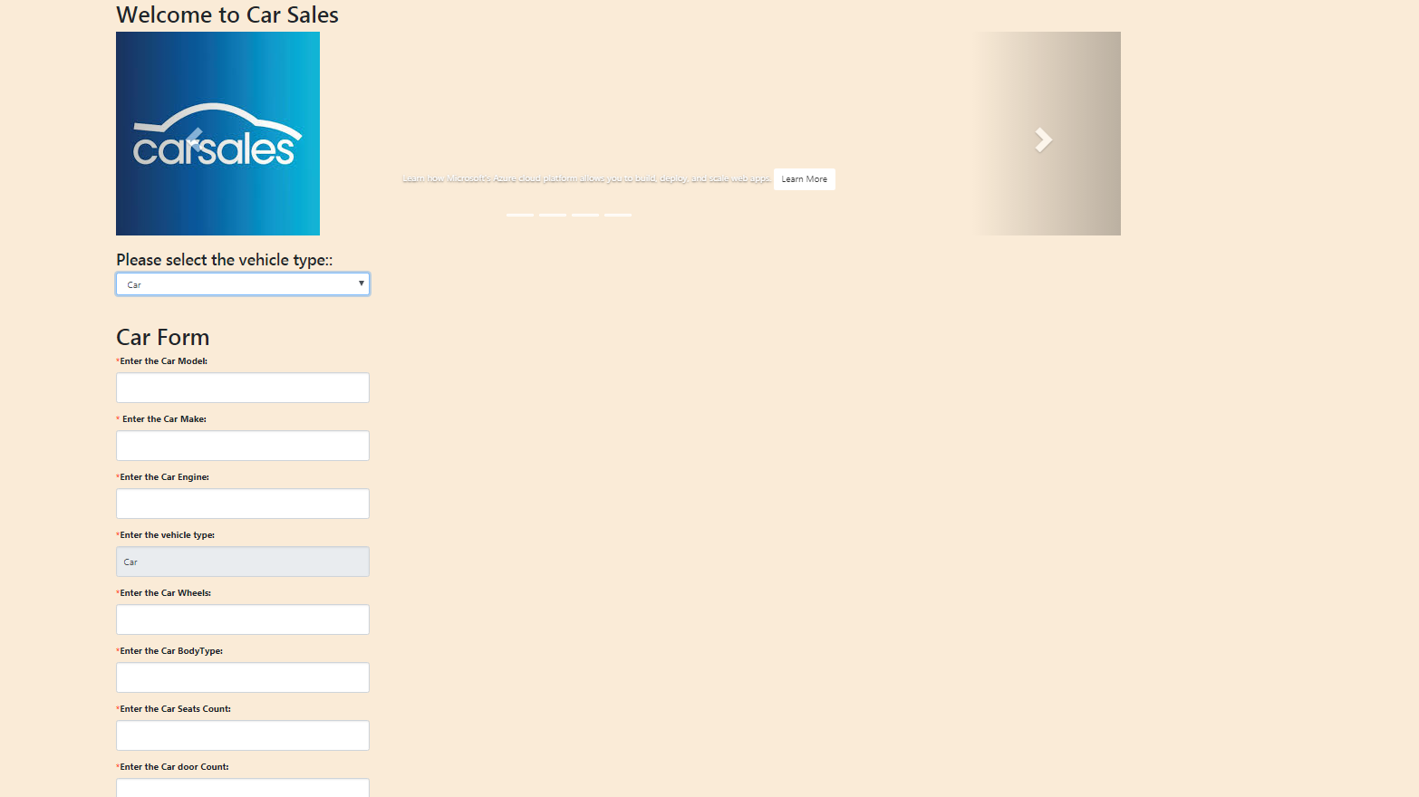

1. Enter the details and click Submit button. Data submitted successfully message will be displayed and data will be saved in memory at the backend. Although there is provision to save this data in database also.

